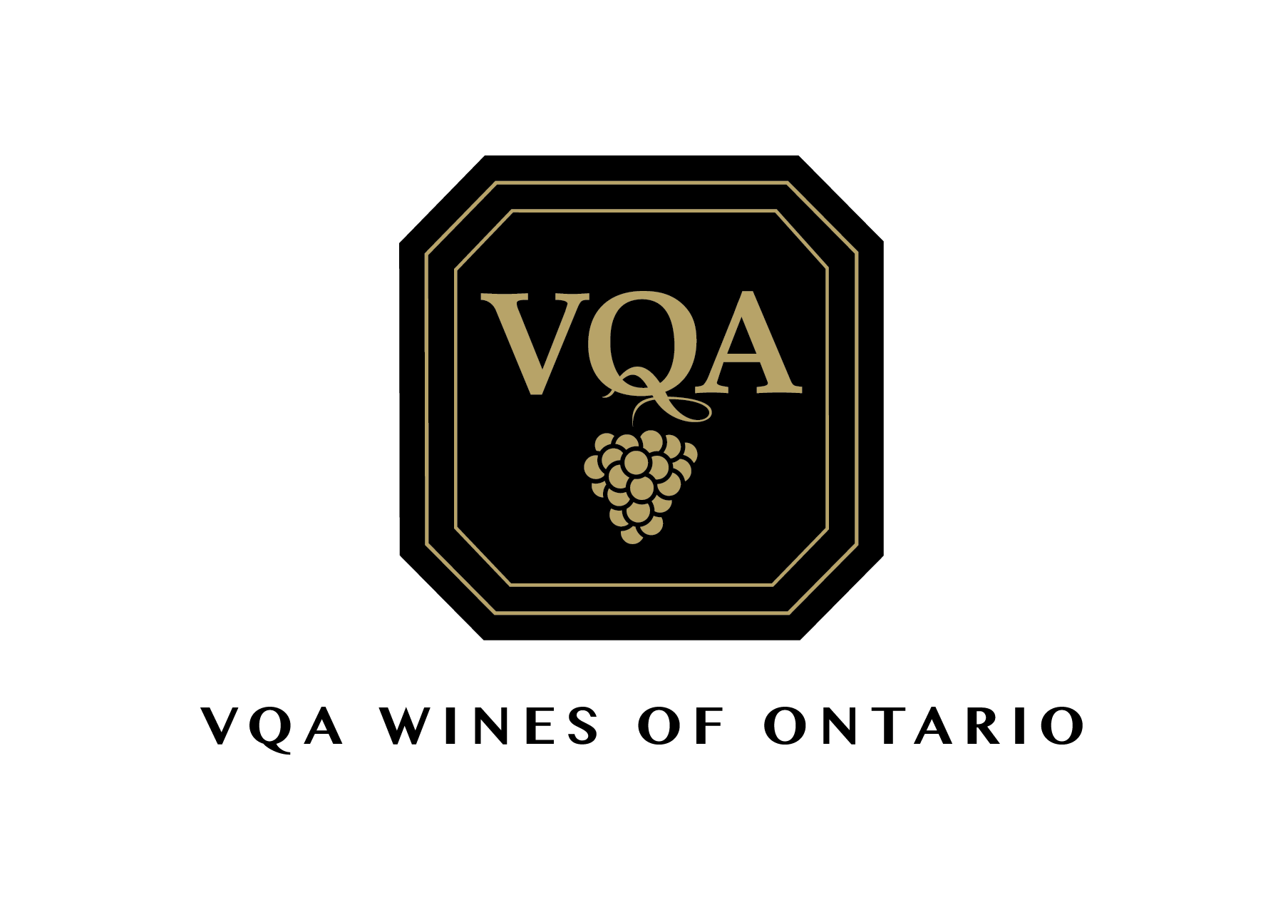
TO: Borderline Systems
140 Cushman Road
St. Catharines, ON L2M 6T6

RE: VQA Wines of Ontario
Ontario Wine Awards 2019
Winery: _____________________
Box ____ of ____

